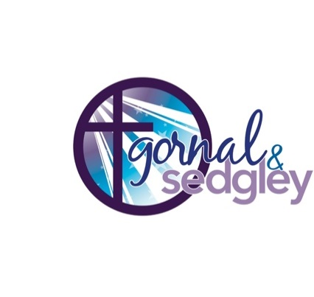**The Parish of Gornal and Sedgley**

Registered Charity Number 1179471

**All Saints’ Sedgley, St Andrew the Straits**

**and St Peter Upper Gornal**

**Parish Office 01902 540189**

**NOTICE SHEET The Sixteenth Sunday After Trinity**

**SHARED WORSHIP**

**Sunday 15th September**

**9.30am Worship for All St Andrews**

**111am Family Service and Fair-Trade Stall All Saints**

**Wednesday 18th September 10am St Peters Holy Communion**

**Sunday 22nd September**

**8am Holy Communion All Saints**

**9.30am Worship for All St Andrews**

**10am Holy Communion and Harvest Festival St Peters**

**COFFEE MORNING,** 10.30am till 12.30pm this Friday All Saints Church in which you are all very welcome

**ZOOM PRAYER MEETING** – will take place on Thursday mornings at 9.15am.

**ALL SAINTS PRAYER MEETINGS CANCELLED** - For those who normally attend the 8:00 prayer meeting on the 1st and 3rd Sundays, and the 11:00 on 4th Sunday. The prayer meetings are cancelled for the next few weeks. Keith is taking a break from his duties as Church Warden to rest and recoup. Any questions please contact Rev Catherine Mitchell

**BLACK COUTRY FOODBANK** **@ HARVEST -** The Foodbank is in desperate need of many items to replenish their shelves before the Winter. Please see the list in church with the Foodbank box. Thanks, from all at 'Springs' to those who continue to donate.

**HARVEST THANKSGIVING AT ST PETER'S -** This will be on Sunday 22nd September 2024 - as part of the Communion service. Everyone is welcome. Donations of tins and packets will be gratefully received for the Good Shepherd, Wolverhampton, to help those in need. Thank you.

**REELING IN THE YEARS –** Please join us in All Saints church hall, Wednesday 19th September 1.30pm for the showing of Singing in the Rain.

**THANK YOU –** We would like to thank Ladies Society very much for the lovely gift and card they gave us on the occasions of our pearl wedding anniversary. God Bless you all. Maureen and David Matthews.

**FAIR TRADE FORTNIGHT 2024 IN SEDGLEY SEPTEMBER 9TH – 22ND -** There will be lots going on this year. Fair Trade Fortnight Plan: Monday 16th Over 50s Group afternoon. Library display Monday 9th. We have a stall in church today, so bring your money along and support Fair Trade!

**Thank you, Fair Trade Team**

**This is the link to the weekly Diocese of Worcester Podcast and sermon:** [**https://www.cofe-worcester.org.uk/your-faith/prayer-worship/sermon-podcasts/sermon-podcasts.php**](https://www.cofe-worcester.org.uk/your-faith/prayer-worship/sermon-podcasts/sermon-podcasts.php) **Church of England online resources INCLUDING SUNDAY SERVICES:** <https://www.churchofengland.org/news-and-media/church-online>

**SAFEGUARDING** - The Parish of Gornal and Sedgley is committed to the safeguarding of children, young people and adults. We follow the House of Bishops guidance. If you or someone you know feels unsafe, please contact the Parish Safeguarding Officer Barbara Baker, Tel 01902 882847, email [safeguarding@allsaintssedgley.co.uk](mailto:safeguarding@allsaintssedgley.co.uk)

or Acting Team Rector Rev Catherine Mitchell Tel 01902 677 897 [vicargornalandsedgley@allsaintssedgley.co.uk](mailto:vicargornalandsedgley@allsaintssedgley.co.uk) (other contacts available on our website [www.gornalandsedgley.org.uk](http://www.gornalandsedgley.org.uk))

**MINISTRY TEAM CONTACTS – Revd** Catherine Mitchell - 01902 677897‬ [revcatherinemitchell13@gmail.com](mailto:revcatherinemitchell13@gmail.com)

|  |  |  |
| --- | --- | --- |
| Canon Jan Humphries -  07954 314102 - [janhumphries@hotmail.co.uk](mailto:janhumphries@hotmail.co.uk)   * follow us on Facebook – ‘Gornal and Sedgley team Ministry’ | https://cofeworcester.contentfiles.net/media/documents/document/2014/12/Kingdom_People_Logo-CMYK.jpg | square, twitter iconfollow us on Twitter - @gornalsedgley |