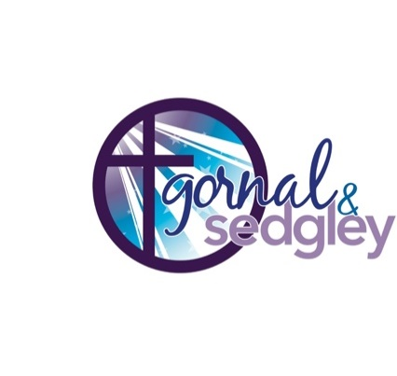**The Parish of Gornal and Sedgley**

Registered Charity Number 1179471

**All Saints’ Sedgley, St Andrew the Straits**

**and St Peter Upper Gornal**

**Parish Office 01902 540189**

**NOTICE SHEET The Nineteenth Sunday After Trinity**

**SHARED WORSHIP**

**Sunday 6th October**

**9.30am Holy Communion St Andrews**

**11am Holy Communion All Saints**

**6.30pm Evensong All Saints**

**Wednesday 9th October 10am St Peters Holy Communion**

**Sunday 13th October**

**8am Holy Communion All Saints**

**9.30am Harvest Festival St Andrews**

**10am Worship for All St Peters**

**11am Holy Communion All Saints**

**COFFEE MORNING,** 10.30am till 12.30pm this Friday All Saints Church in which you are all very welcome

**ZOOM PRAYER MEETING** – will take place on Thursday mornings at 9.15am.

**ALL SAINTS PRAYER MEETINGS CANCELLED** - For those who normally attend the 8:00 prayer meeting on the 1st and 3rd Sundays, and the 11:00 on 4th Sunday. The prayer meetings are cancelled for the next few weeks. Keith is taking a break from his duties as Church Warden to rest and recoup. Any questions please contact Rev Catherine Mitchell

**BISHOPS CERTIFICATE COURSE -** There are several Bishop’s Certificate courses being run in the diocese which will be starting this term. The nearest one to us will run in at St James's Church, Wollaston (Stourbridge), on Thursday evenings, starting on 24th October. For further information about the Bishop’s Certificate Course please do look at our website here which also includes information on how to apply. <https://www.cofe-worcester.org.uk/your-faith/courses-group-resources/bishops-certificate/bishops-certificate>

**FUNERALS –** the funeral of the late David Siverns will take places at Gornal wood 9th October at 2.50pm. On the 10th the funeral of the late Patricia Ann Taylor will take place at All Saints 12.30pm. 11th October the funeral of the late William Donald Davies will take place at Gornal Wood 1.30pm. Our thoughts and prayers go to all their families at this very sad time.

**FAIR TRADE CHRISTMAS CARDS -** There are 16 lovely designs available. There will be packs to show you soon.

If you are interested in supporting us, please let Gail or Cicely know. Packs should be available in October.

**ALL SAINTS CHRISTMAS FAIR - SATURDAY 7th DECEMBER**

We are hoping to hold our Christmas Fair again if there is enough support. There will be a short meeting to discuss this on Tuesday, 8th October at 4pm in the Community Room at the back of the Church Hall. If you are able to help please come to the meeting or get in touch with me on 01902 672541. Mary Zielonka

**LAUGHING YOGA:** Guaranteed good for the soul!

Join our Wednesday morning drop-in group for a one off free **Laughing Yoga session on Wednesday 9th October** in the Community Room of the Church Hall - 10am.

There will be cake!!

**LADIES SOCIETY -** Following a request from Dave Heeley, it has been necessary to alter the events programme as follows:

Dave will now be talking to us on Monday 4th November, and our speaker for Monday 7th October will be Geoff Shaw. Thank you

Barbara Price.

**BLACK COUTRY FOODBANK** **@ HARVEST -** The Foodbank is in desperate need of many items to replenish their shelves before the Winter. Please see the list in church with the Foodbank box. Thanks, from all at 'Springs' to those who continue to donate.

**This is the link to the weekly Diocese of Worcester Podcast and sermon:** [**https://www.cofe-worcester.org.uk/your-faith/prayer-worship/sermon-podcasts/sermon-podcasts.php**](https://www.cofe-worcester.org.uk/your-faith/prayer-worship/sermon-podcasts/sermon-podcasts.php) **Church of England online resources INCLUDING SUNDAY SERVICES:** <https://www.churchofengland.org/news-and-media/church-online>

**SAFEGUARDING** - The Parish of Gornal and Sedgley is committed to the safeguarding of children, young people and adults. We follow the House of Bishops guidance. If you or someone you know feels unsafe, please contact the Parish Safeguarding Officer Barbara Baker, Tel 01902 882847, email [safeguarding@allsaintssedgley.co.uk](mailto:safeguarding@allsaintssedgley.co.uk)

or Acting Team Rector Rev Catherine Mitchell Tel 01902 677 897 [vicargornalandsedgley@allsaintssedgley.co.uk](mailto:vicargornalandsedgley@allsaintssedgley.co.uk) (other contacts available on our website [www.gornalandsedgley.org.uk](http://www.gornalandsedgley.org.uk))

**MINISTRY TEAM CONTACTS – Revd** Catherine Mitchell - 01902 677897‬ [revcatherinemitchell13@gmail.com](mailto:revcatherinemitchell13@gmail.com)

|  |  |  |
| --- | --- | --- |
| Canon Jan Humphries -  07954 314102 - [janhumphries@hotmail.co.uk](mailto:janhumphries@hotmail.co.uk)   * follow us on Facebook – ‘Gornal and Sedgley team Ministry’ | https://cofeworcester.contentfiles.net/media/documents/document/2014/12/Kingdom_People_Logo-CMYK.jpg | square, twitter iconfollow us on Twitter - @gornalsedgley |